Database Description
The Hospital Management System's database is designed to manage core healthcare operations, focusing on user administration, appointment scheduling with associated fees and time slots, and payment logging. The system supports multiple user roles: administrators, doctors, staff, and patients, ensuring foundational functionality for administrative personnel, medical staff, support staff, and patients. The database plays a vital role in maintaining data consistency, managing appointment scheduling (PatientSlots, Appointment), payments (Payment), and providing a secure base for accessing relevant medical interaction information.
User Role Management
- Administrator Management (Admin model) The Admin table stores details of system administrators who manage basic system data. Administrators can oversee user information and potentially monitor system activities. Key fields include personal details (firstName, lastName, address, phone), demographic information (dob (mapped as date_of_birth), age, gender using the Gender enum), and security credentials (email and password). Timestamps (createdAt, updatedAt) track record changes.
- Doctor Management (Doctor model) The Doctor table maintains comprehensive information about physicians registered within the system. Doctors are linked to the appointments they conduct (appointments relation) and the time slots they offer (patientSlots relation). The table captures essential attributes including personal information (firstName, lastName, address, phone), demographic details (dob (mapped as date_of_birth), age, gender using the Gender enum), and security credentials (email, password). Timestamps (createdAt, updatedAt) are included.
- Staff Management (Staff model) The Staff table holds information for non-clinical hospital staff members. This role might include receptionists, administrative assistants, or other support personnel involved in hospital operations but not directly providing medical consultation tracked via appointments in this schema. Key fields include personal details (firstName, lastName, address, phone), date of birth (dob), and their assigned role. Timestamps (createdAt, updatedAt) track record changes.
- Patient Management (Patient model) The Patient table maintains information about individuals receiving medical care through the system. Patients can be linked to appointments they schedule (appointments relation). The system captures detailed patient attributes, including personal information (firstName, lastName, address, phone), demographic data (dob, age, gender using the Gender enum), physical measurements (height and weight), and security credentials (email, password). Timestamps (createdAt, updatedAt) are included.
Appointment Scheduling and Payment Management
- Doctor Availability (PatientSlots model) The PatientSlots model defines the available time slots for doctors on specific days of the week. Each slot has a day (using the Day enum), startTime, and endTime. It is linked to a specific doctor via doctorId and holds a list of appointments scheduled within that slot. This model is crucial for managing doctor schedules and appointment booking availability. Timestamps (createdAt, updatedAt) are included.
- Appointment Management (Appointment model) The Appointment table tracks scheduled consultations between patients and doctors, including the associated cost (fee). It serves as a bridge connecting Patient records, Doctor records, and specific PatientSlots. Each appointment is uniquely identified (id), includes details like type and status . It is linked viapatientId, doctorId, and slotId using ObjectId references. It also has an optional relation (payment) to a Payment record, indicating if a payment has been logged for this appointment. Timestamps (createdAt, updatedAt) are included.
- Payment Processing (Payment model) The Payment table records financial transactions specifically related to appointments. Each payment record corresponds to exactly one appointment, establishing a one-to-one relationship enforced by the unique appointmentId field and patientId field . Payment details include amount and paymentMethod. It contains the required, unique appointmentId field linking it back to the specific Appointment it covers, along with a corresponding relation field appointment. Timestamps (createdAt, updatedAt) track the payment record's creation and modification.
In conclusion, the Hospital Management System's database architecture, based on the provided Prisma schema, ensures foundational interaction between administrators, medical staff (doctors), support staff, and patients by managing user roles, doctor availability (PatientSlots), appointments with associated fees, and their corresponding payments. With role-based data structures and integrated scheduling and payment tracking, the database plays a critical role in organizing core healthcare interactions and financial records. It enhances operational clarity for providers and provides patients with a structured system for managing their scheduled appointments and payments.

Table Name | Description
Admin | Stores details of system administrators responsible for managing basic system data and overseeing user information.
Doctor | Maintains comprehensive information about physicians, linking them to their available time slots and scheduled appointments.
Staff | Holds information for non-clinical hospital staff members involved in hospital operations (e.g., receptionists, administrative assistants).
PatientSlots | Defines the available time slots for doctors on specific days, managing doctor schedules and appointment booking availability.
Patient | Maintains information about individuals receiving medical care, linking them to their scheduled appointments.
Appointment | Tracks scheduled consultations between patients and doctors within specific time slots, including details like fee, type, and status.
Payment | Records financial transactions specifically related to appointments, linking each payment uniquely to one appointment.

ER Diagram
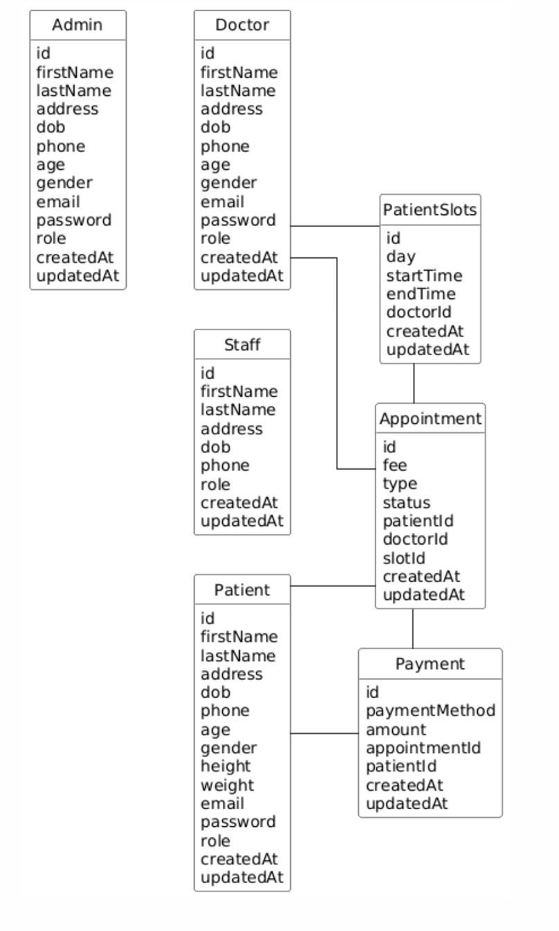

Sample Data
{
"admins": [
{
"id": "admin_id_1",
"firstName": "Alice",
"lastName": "Smith",
"address": "100 Admin Way, Suite 10",
"dob": "1980-05-15T00:00:00.000Z",
"phone": "555-0101",
"age": 44,
"gender": "FEMALE",
"email": "alice.smith@hospital.admin",
"password": "hashed_password_admin",
"role": "ADMIN",
"createdAt": "2023-01-10T08:00:00.000Z",
"updatedAt": "2023-10-15T10:30:00.000Z"
}
],
"doctors": [
{
"id": "doctor_id_1",
"firstName": "Bob",
"lastName": "Jones",
"address": "200 Clinic Rd",
"dob": "1975-08-20T00:00:00.000Z",
"phone": "555-0202",
"age": 48,
"gender": "MALE",
"email": "bob.jones@hospital.doc",
"password": "hashed_password_doc1",
"role": "DOCTOR",
"createdAt": "2023-01-15T09:00:00.000Z",
"updatedAt": "2023-11-01T11:00:00.000Z"
},
{
"id": "doctor_id_2",
"firstName": "Carol",
"lastName": "Williams",
"address": "250 Health Ave",
"dob": "1982-11-30T00:00:00.000Z",
"phone": "555-0203",
"age": 41,
"gender": "FEMALE",
"email": "carol.williams@hospital.doc",
"password": "hashed_password_doc2",
"role": "DOCTOR",
"createdAt": "2023-02-01T10:00:00.000Z",
"updatedAt": "2023-11-20T14:00:00.000Z"
}
],
"staff": [
{
"id": "staff_id_1",
"firstName": "David",
"lastName": "Brown",
"address": "300 Reception Blvd",
"dob": "1990-03-25T00:00:00.000Z",
"phone": "555-0303",
"role": "STAFF",
"createdAt": "2023-03-01T08:30:00.000Z",
"updatedAt": "2023-09-01T16:00:00.000Z"
}
],
"patients": [
{
"id": "patient_id_1",
"firstName": "Eve",
"lastName": "Davis",
"address": "400 Patient St",
"dob": "1995-06-10T00:00:00.000Z",
"phone": "555-0404",
"age": 28,
"gender": "FEMALE",
"height": 1.65,
"weight": 60.5,
"email": "eve.davis@email.com",
"password": "hashed_password_patient1",
"role": "PATIENT",
"createdAt": "2023-04-01T11:00:00.000Z",
"updatedAt": "2023-11-15T09:45:00.000Z"
},
{
"id": "patient_id_2",
"firstName": "Frank",
"lastName": "Miller",
"address": "450 Wellness Ln",
"dob": "1988-12-05T00:00:00.000Z",
"phone": "555-0405",
"age": 35,
"gender": "MALE",
"height": 1.80,
"weight": 85.2,
"email": "frank.miller@email.com",
"password": "hashed_password_patient2",
"role": "PATIENT",
"createdAt": "2023-05-10T14:20:00.000Z",
"updatedAt": "2023-12-01T10:10:00.000Z"
}
],
"patientSlots": [
{
"id": "slot_id_1",
"day": "MONDAY",
"startTime": "2024-01-15T09:00:00.000Z", // Example specific date/time
"endTime": "2024-01-15T09:30:00.000Z",
"doctorId": "doctor_id_1",
"createdAt": "2023-12-15T10:00:00.000Z",
"updatedAt": "2023-12-15T10:00:00.000Z"
},
{
"id": "slot_id_2",
"day": "MONDAY",
"startTime": "2024-01-15T09:30:00.000Z",
"endTime": "2024-01-15T10:00:00.000Z",
"doctorId": "doctor_id_1",
"createdAt": "2023-12-15T10:00:00.000Z",
"updatedAt": "2023-12-15T10:00:00.000Z"
},
{
"id": "slot_id_3",
"day": "TUESDAY",
"startTime": "2024-01-16T14:00:00.000Z",
"endTime": "2024-01-16T14:30:00.000Z",
"doctorId": "doctor_id_2",
"createdAt": "2023-12-16T11:00:00.000Z",
"updatedAt": "2023-12-16T11:00:00.000Z"
}
],
"appointments": [
{
"id": "appointment_id_1",
"fee": 75.00,
"type": "CONSULTATION",
"status": "CONFIRMED",
"patientId": "patient_id_1",
"doctorId": "doctor_id_1",
"slotId": "slot_id_1",
"createdAt": "2024-01-05T10:00:00.000Z",
"updatedAt": "2024-01-05T10:05:00.000Z"
},
{
"id": "appointment_id_2",
"fee": 120.50,
"type": "DIAGNOSIS",
"status": "CHECKED_IN",
"patientId": "patient_id_2",
"doctorId": "doctor_id_2",
"slotId": "slot_id_3",
"createdAt": "2024-01-10T11:30:00.000Z",
"updatedAt": "2024-01-16T13:55:00.000Z" // Updated when checked in
}
],
"payments": [
{
"id": "payment_id_1",
"paymentMethod": "CREDIT_CARD",
"amount": 75.00,
"appointmentId": "appointment_id_1", // Links to the first appointment
"patientId": "patient_id_1", // Links to the patient of that appointment
"createdAt": "2024-01-05T10:15:00.000Z",
"updatedAt": "2024-01-05T10:15:00.000Z"
},
{
"id": "payment_id_2",
"paymentMethod": "INSURANCE",
"amount": 120.50,
"appointmentId": "appointment_id_2", // Links to the second appointment
"patientId": "patient_id_2", // Links to the patient of that appointment
"createdAt": "2024-01-16T14:10:00.000Z", // Paid after check-in
"updatedAt": "2024-01-16T14:10:00.000Z"
}
]
}

